**OUTPUTS FOR WORKFORCE ADMINISTRATION DEVELOPMENT**

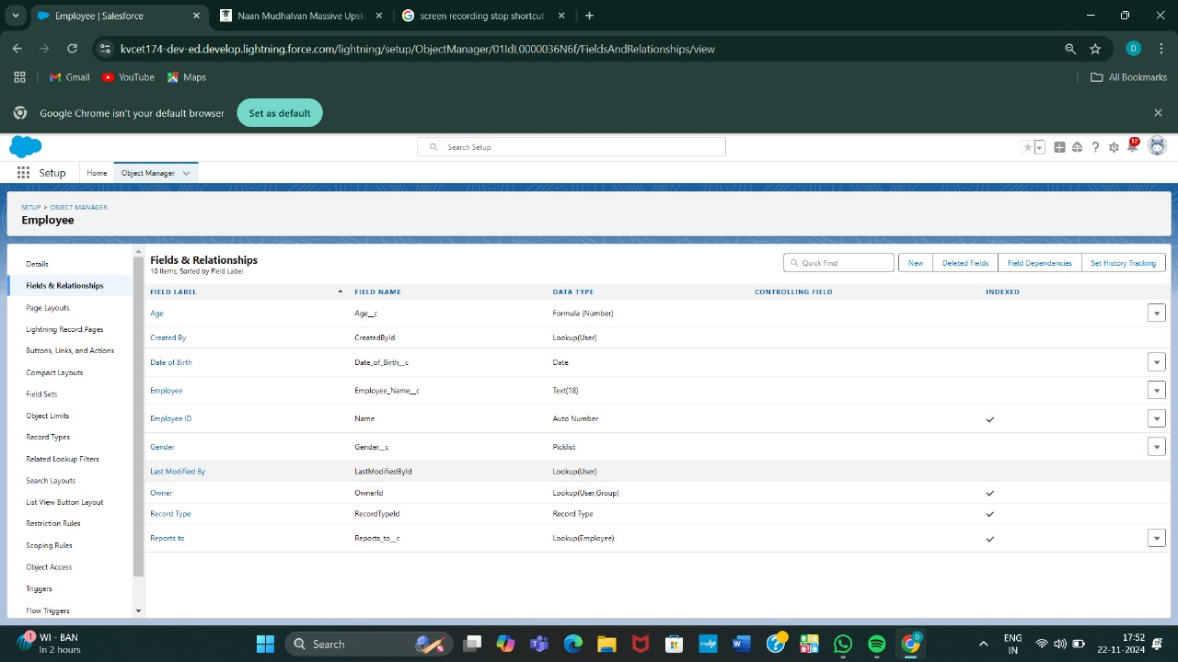

**OUTPUT 2**

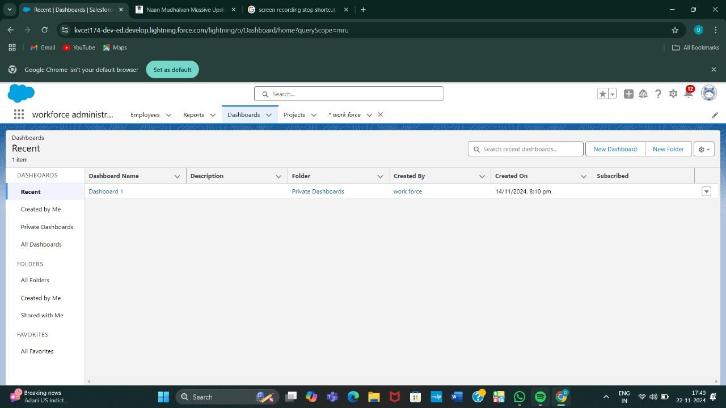

**OUTPUT 3**

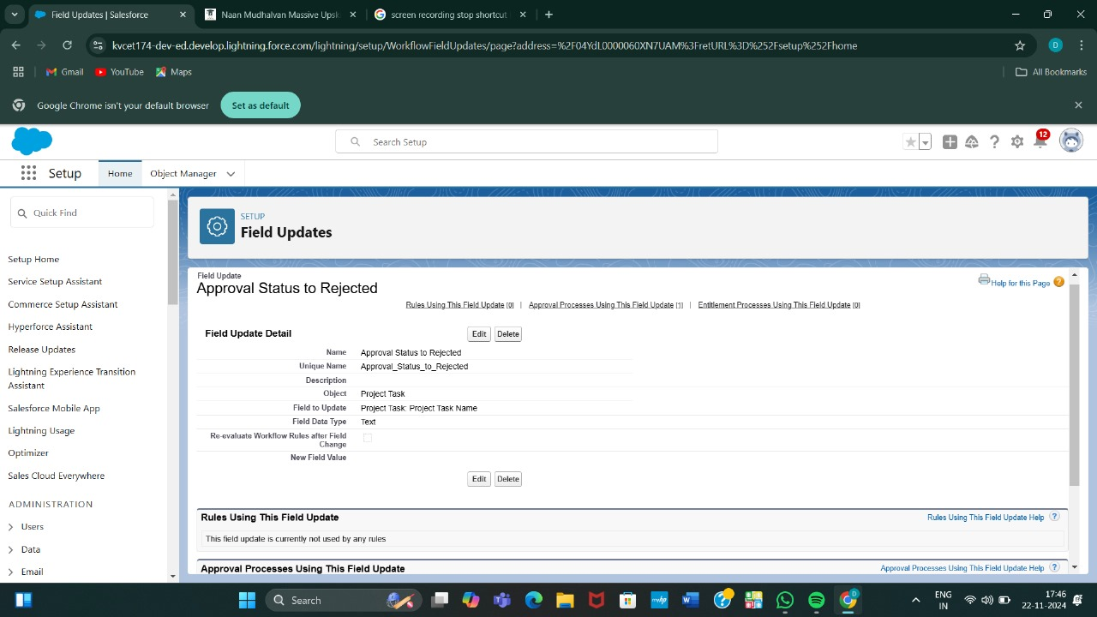

**OUTPUT 4**

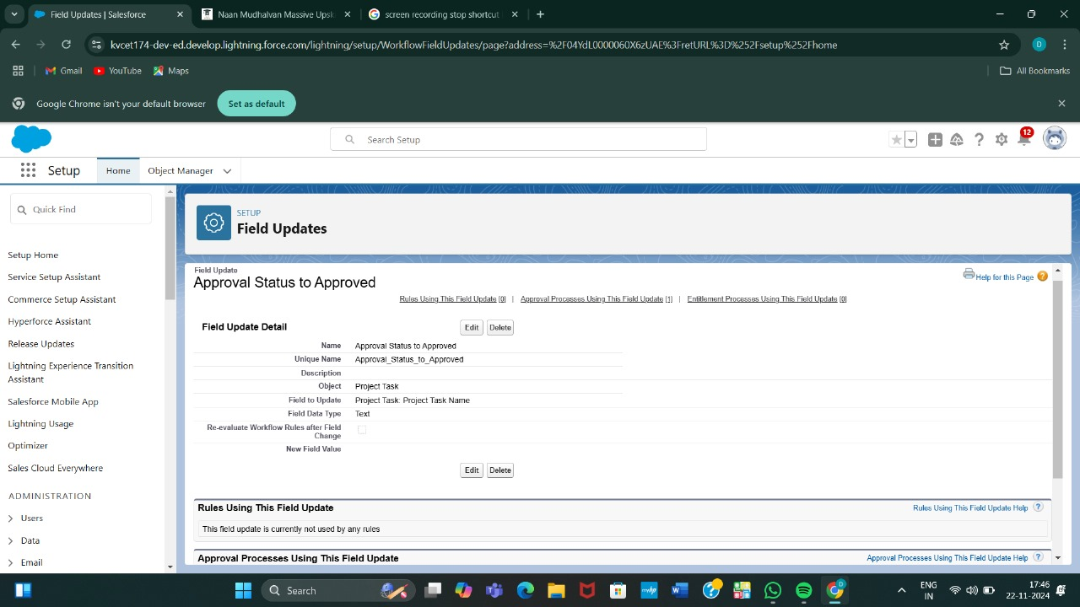

**OUTPUT 5**

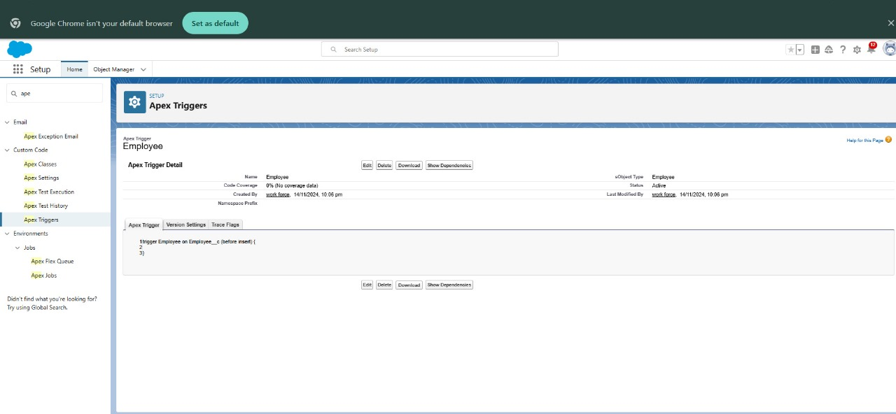

**OUTPUT 6**

